

BHARAT INSTITUTE OF ENGINEERING AND TECHNOLOGY
Approved by AICTE, New Delhi
Accredited by NBA & NAAC | Affiliated to Jawaharlal Nehru Technological University | Hyderabad

DEPARTMENT OF CSE(AI&ML) 30.05.2026

Project Stage I Guidelines
- The UG project shall be initiated at the end of the IV Year I Semester and the duration of the project work is one semester. The student must present Project Stage – I during IV Year I Semester before II Mid examinations, in consultation with his Supervisor, the title, objective and plan of action of his Project work to the departmental committee for approval before commencement of IV Year II Semester. Only after obtaining the approval of the departmental committee, the student can start his project work.
- UG project work shall be carried out in two stages: Project Stage – I for approval of project before Mid-II examinations in IV Year I Semester and Project Stage – II during IV Year II Semester. Student has to submit project work report at the end of IV Year II Semester. The project shall be evaluated for 100 marks before commencement of SEE Theory examinations.
- For Project Stage – I, the departmental committee consisting of Head of the Department, project supervisor and a senior faculty member shall approve the project work to begin before II Mid-Term examination of IV Year I Semester. The student is deemed to be not eligible to register for the Project work, if he does not submit a report on Project Stage - I or does not make a presentation of the same before the evaluation committee as per schedule.
- A student who has failed may reappear once for the above evaluation, when it is scheduled again; if he fails in such ‘one reappearance’ evaluation also, he has to reappear for the same in the next subsequent semester, as and when it is scheduled.
- Super guide should make sure that all the student batches under his supervision are allocated with projects. If so, any batch is left out with projects the super guide must allot the project.
- The students should report to their respective guides at least once in a week.
- The guide must submit the report to the class teacher by the end of the week for attendance upload in the College Automation.
- The progress of the students will be closely monitored by the super guides with the help of AGs and PGs.
- There should be a review conducted by the CPC along with students with the help of AGs and PGs every fortnight. The attendance of the students and the performance in the reviews will be seriously monitored.
- The review schedules and what to be submitted in those reviews are given below.

NOTE 1: EACH PROJECT BATCH MUST CONTAIN AT MOST 4 MEMBERS ONLY

NOTE 2: All students are informed that only Research-oriented projects or Real-Time application projects will be considered for evaluation. Simple implementations, or purely academic exercises will not be accepted.
NOTE 3: Students are advised to select project topics that address real-world problems, industry needs, or research challenges, and demonstrate innovation, analysis, and practical relevance.
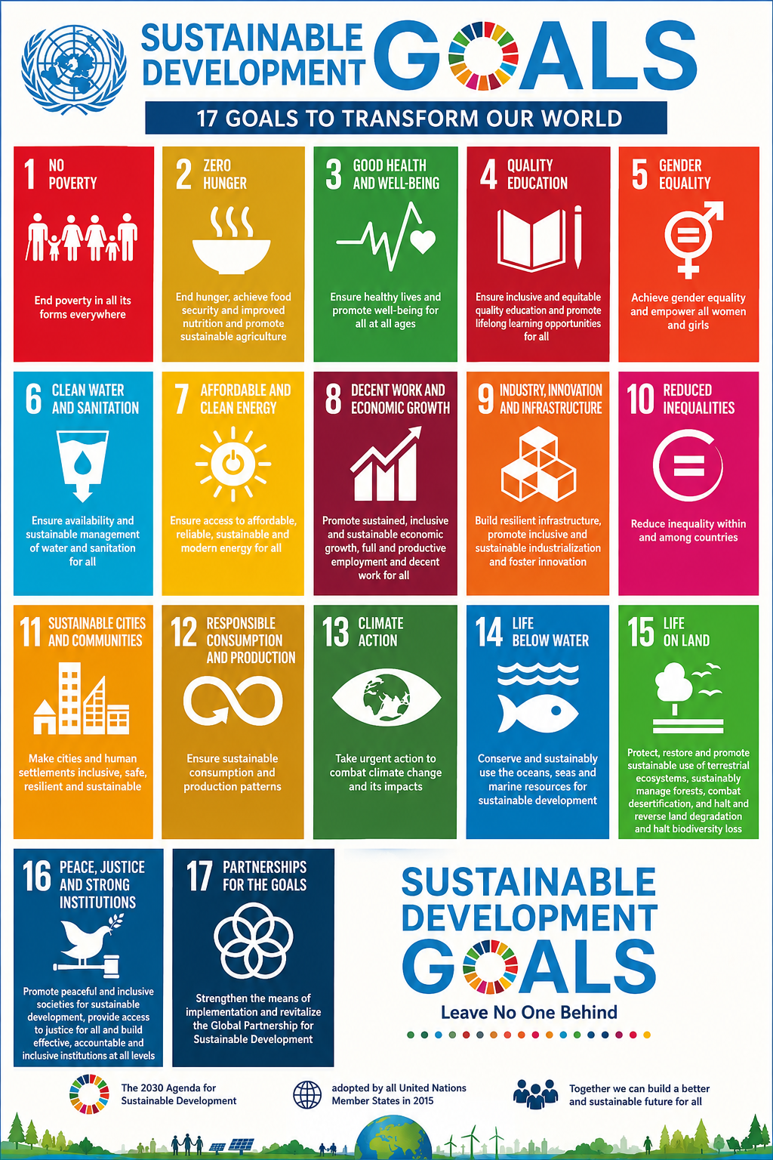
NOTE 4: All Final Year Project Students are hereby informed to identify and select a Project Stage–I topic that addresses one or more of the United Nations Sustainable Development Goals (SDGs).

Description | From | To
Identification of SDG-aligned problem statement | 11.06.2026 | 06.07.2026
Literature Survey and Related Work Analysis | 20.07.2026 | 25.07.2026
Finalization of Project Title and Objectives | 03.08.2026 | 08.08.2026
Requirement Analysis and Feasibility Study | 10.08.2026 | 15.08.2026
Dataset Collection / Resource Identification | 17.08.2026 | 22.08.2026
Prototype Design / Initial Development | 24.08.2026 | 29.08.2026
Preparation of Stage-I Report | 07.09.2026 | 12.09.2026
Internal Review and Submission of Report | 05.10.2026 | 12.10.2026

- The above instructions must be followed strictly to complete the project. The PGs are responsible for the completion of the project and any discrepancy in the process flow can be brought to the notice of the committee.
- The evaluation plan for Project Stage I is shown in the following table.

- 3 Credits
- L-T-P -0-0-3
- Year/ Semester: IV/I

Internal evaluation
Project committee members:
- Head of the Department
- Supervisor of the project
CPC, Super Guide
Total | --

Project Stage I

SD/- SD/-

PROJECT COORDINATOR HOD

